

**CS7CS4/CSU44061**

**Machine Learning**

Week 2 Assignment

*Aaron McCann*

*20332462*

03/10/2024

**Introduction**

**Assignment**

***A(i):***

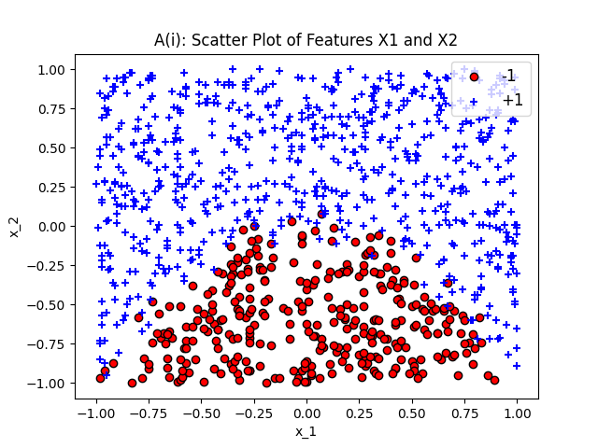

Figure 1: Scatter of Features X1 and X2

The graph above helps to visualize the input data. X1 can be seen on the X axis and X2 on the Y axis. The data is separated into two classes. The targets for the two classes are Y = 1 and Y = -1. The marker + is used to represent y = 1 and the marker o is used to represent y = -1.

The graph shows that the classes can roughly be split with a straight line, although not perfectly. For this reason, the linear regression algorithm will perform well on the data.

***A(ii):***

A logistic regression classifier is trained on the data.

The intercept is 2.01. This represents the bias term that shifts the direction of the decision boundary. The intercept is positive and this means that the logistic regression model predicts more positive classes(+1) then negative classes (-1). A positive intercept pushed the decision boundary towards +1 because it increases the value of the logit function.

The Cofientesr are as follows:

X1: -0.054

The small coefficient for X1 meaning that changes to X1 don’t affect the predictions as much.

X2: 5.94

The coefficient for X2 is much larger and this shows that it has a stronger impact on the model’s predictions.

The coefficients show that X2 will have bigger influence on the changes in the decision boundary. This si because coeficients determine the slope of the boundary and aleger ones will will move the boundary towards that feature. In this case the formula for the coundry is :(-0.054)X1 + (5.94)X2 + b. Its clear that because we multiply 5.94 by X2, X2 will have much more impact on the final result.

***A(iii):***

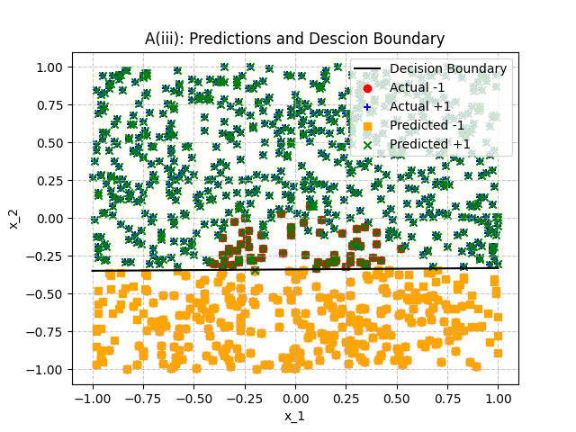

Figure 2:

The actual -1 can be seen represented as a red dot. The actual +1 are represented with a blue plus sign. The predicted points are seen on the same plot with predicted +1 shown as green crosses and predicted -1 shown as orange squares.

***A(iv):***

***B(i):***

***B(ii):***

***B(iii):***

***B(iv):***

***C(i):***

***C(ii):***

***C(iii):***

***C(iv):***

**Conclusion**